MAT 3749 2.4 Handout
Rolle’s Theorem
Let be continuous on and differentiable on such that . Then such that .

The Mean Value Theorem
Let be continuous on and differentiable on . Then such that
.

Cauchy’s Mean Value Theorem
Let and be continuous on and differentiable on . Then such that
.
In particular, if and , then
.

Analysis  What are the seminaries and differences between Rolle’s Theorem and the CMVT? | Seminaries:  Differences:
Guess an approach to prove the MVT.

Recall our experience with proving the MVT from Rolle’s Theorem.  The equation of the secant line is  Let . Then, we check the 3 conditions for Rolle’s Theorem. | 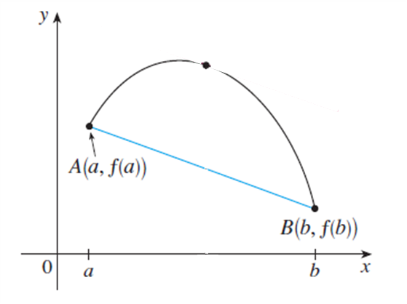
For the same token, let us create a function that would help us to get to the conclusion of the CMVT.

If satisfies the hypotheses of Rolle’s Theorem, what would be the conclusion?

What is the conclusion that we want?

Can you rewrite the last expression so that it is similar to the one from Rolle’s Theorem?

Compare! What could be a possible definition for ?

is continuous on . Why?
(c.f. is differentiable on )

. Why?

Proof

Let on .

and are continuous on and differentiable on . Since is a linear combinations of and , it is also continuous on and differentiable on .

Then on .

Also,
That is, .

By Rolle’s Theorem, such that

Remarks
1. The Mean Value Theorem is a special case of Cauchy’s Mean Value Theorem.

Compare CMVT and the MVT side-by-side.

Let and be continuous on and differentiable on . Then such that …… then  . | Let be continuous on and differentiable on . Then such that  .
What is a possible choice of so that the conclusion of the MVT follows from the conclusion of CMVT?

Proof

Let . Then is continuous on and differentiable on .

Also, and .

By Cauchy’s MVT, such that

2. Cauchy’s Mean Value Theorem is NOT a consequence of the Mean Value Theorem.

If we apply the MVT to and , such that
and

l’Hospital’s Rule Version 1
Let and be differentiable on a neighborhood of , at which .
If exists, then exists and equal to .

Analysis

1. Let us look at how Cauchy’s MVT can help us to prove l’Hospital’s Rule.
2. We will need to check all the hypotheses of Cauchy’s MVT.

Conceptual Diagram

Cauchy’s MVT requires the existence of intervals and . In order to make it work, let us create another point, say on the right side of . Now we have the intervals and .
By Cauchy’s MVT, such that…

How is this similar to what we want to prove?

From our diagram, if we take the limit as , what kind of limit is this?

When, what is approaching?

Show that

From symmetry, it is not difficult to prove the other side of the limit:
.

There are 4 conditions that we need to check before we can use Cauchy’s MVT. They are… | 1.  2.  3.  4.
What conditions do we have to prove the 4 conditions above? | A.  B.  C.
We can use (A) to prove (1) and (2).
We have already used (B).

So, (C) must be involved in proving (3) and (4). It turns out that we need to use both (A) and (C) to show that which implies (3) and (4).

Let . Write down the definition of .

Why the definition above implies that is defined on .

Why does this imply
1. on and
2. and are differentiable on ?

What is the difference between and ?

Why and are also differentiable at ?

So, and are differentiable and therefore continuous on .

Proof
Suppose .
Let . Then such that if , then.
In particular, is defined on .
This implies
1. on .
2. and are differentiable on .
Also, and are differentiable on a neighborhood of
and are differentiable at
So, and are differentiable and therefore continuous on .

Let . Then and are continuous on and differentiable on .
By Cauchy’s MVT, Then such that
Now,
1. since .
2. . Otherwise, by Rolle’s Theorem, for some which is a contradiction to on .
Thus,
As , . So,
Similarly, we can prove that.
Thus, .

